With the arrival of Enhanced Customer Experience, formerly known as TWC Maxx, there are some changes that we all need to be aware of.
Sources: http://key.twcable.com/Pages/TWCMaxx.aspx http://key.twcable.com/Pages/TWCMaxxInternetSpeedUpgrade.aspx

The speed increase took place on 3/17/2014 in Costa Mesa and West Hollywood.

The speed increases will be as follows:

CSG Description | Statement Description | Current Mbps Speeds Up to | New Mbps Speeds Up to | Replacement Rule for Equipment and Speed Increase
Everyday Low Price (ELP) | Everyday Low Price (ELP) | 2/1 | 3/1 | No equipment change - speeds 1.5x faster
Basic | Basic | 3/1 | 10/1 | No equipment change – speeds more than 3x faster
Standard | Extreme | 15/1 | 50/5 | Equipment swap 1.0 or 2.0 speeds more than 3x’s faster
Turbo | Ultimate 100 | 20/2 | 100/10 | Equipment swap 2.0 (16x4) speeds 5x faster
Extreme | Ultimate 200 | 30/5 | 200/20 | Equipment swap 2.0 (16x4) speeds up to 6x faster
Ultimate | Ultimate 300 | 50/5 | 300/20 | Equipment swap 2.0 (16x4) speeds 3x faster

What this means to you:
*Standard and above in these areas can NO LONGER use a Docsis 2 cm.
*Standard and below should have a D3 cm with at least 4X4 (upstream and downstream channels)
*Turbo and above needs a D3 cm with 16X4 recommended. Technically, the 8 downstream channels have a max of 304Mbps and 16 is 608Mbps.

The easiest way to tell is in Docsis. Samuel McLaughlin sent out a pic showing the 4X4 posted below:
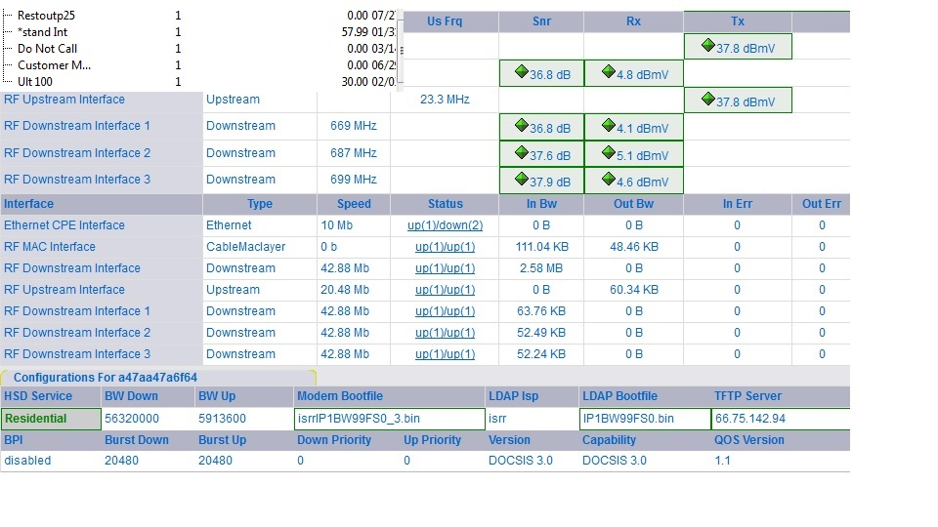
You'll notice the binfile, BW99 is for 100 Mbps, but this cm is only getting 50. That is because the cm only has 4X4 upstream/downstream chs.

Below shows the 8X8 which can handle even the highest speeds we offer, but KEY recommends getting a 16X4 for greater bandwidth:
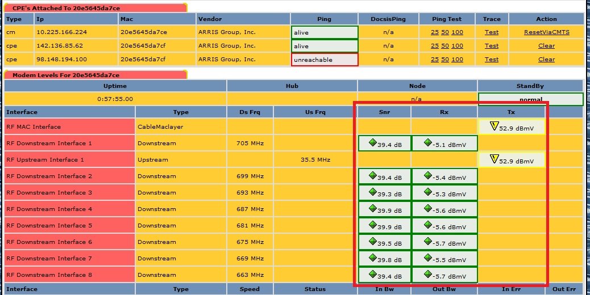
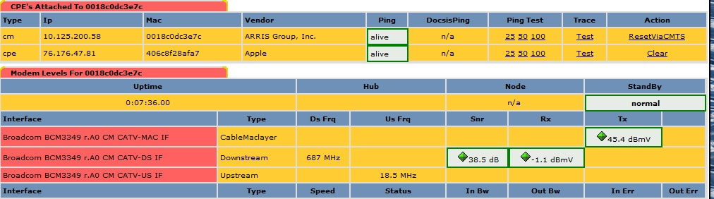
Below is an example of a D2 cm. These only support speeds up to 20Mbps.
ALL D2 CM's will show this way.

KEY has a CM list showing which cm's are compatible with the different speeds we offer, but it's not updated to the ECE speeds and it's easier to tell in Docsis.

Recap:
D2 cm's can only support up to 20Mbps
D3 4X4 can only support up to 50Mbps
D3 8X4 can support up to 304Mbps (recommended for Standard or below)
D3 16X4 can support up to 608Mbps (recommended for 100Mbps and above)

Keep in mind that the max speed of a cm is not a continual speed. Running a D3 8X4 cm at max speeds for any length of time will overheat the cm causing cm rebooting itself and early equip failure.

How the NIC affect speeds:
There are 3 different types of NIC adapters.
Traditional is up to 11Mbps
Fast is up to 100Mbps
Gigabit is up to 1000Mbps
You can usually tell which adapter a computer is using in the Device Manager. The name will generally say either “Family Fast Ethernet Adapter” or 100/1000 Ethernet controller. Just keep in mind that the ones that say “Fast” are only up to 100Mbps. If they have 1000 in the name, then it will support our fastest speeds.
How WNIC affect speeds: (Wireless)
There are 4 types of WNIC adapters. Our customers will generally use 2 of them which I will go over.
802.11g – Any device connecting using wireless G will have a max speed of 54Mpbs
802.11n – Any device connecting using wireless N will have a max speed of 300Mbps
The other 2 types are wireless A and Wireless AC. Wireless A is a max of 54Mpbs and Wireless AC maxes at 1000Mbps.

Keep in mind that wireless networks will rarely see the max speeds. They will generally average at about half(or less) of the max. Wireless A/G will average about 20Mbps and Wireless N at about 100+Mbps. In the real world, an Enet connection at 100 Mbps will run faster than a wireless N at 300 Mpbs.

More information on wireless N and channel bonding:
Has anyone ever noticed the setting in our gateway for channel bonding?
It's the one that will generally show as 20MHz and has an option for 40MHz. Although wireless N has a max speed of 300 Mbps, when on 20MHz, that gets cut to a max of 150 Mpbs. Why? Wireless N has the option of utilizing channel bonding (just like the wired connections) and only uses 1 downstream channel on 20 MHz. 40 MHz utilizes 2 channels doubling the max download speeds. On the other side of that coin, using channel bonding increases the risk of interference with nearby Wi-Fi networks due to the increased spectrum and the additional power it uses. In addition, if running in 40 MHz and there is just 1 device running wireless G or below, the overall performance of the throughput in the router will be less. In near perfect conditions, a single wireless N computer connected in 40 MHz will only yield about 200 Mbps even though the max says 300 Mbps.

Known issues with new Arris Gateway:
* Docsis will not pull any signal information on these (DG1670A)
* RIO will not any info on these
* Unified will pull a general signal level, but will not show all 16 chs.
* No HTTP nor Telnet button anywhere.
* At this point, there is no remote logon information available.
* Local access is 192.168.0.1 using admin/password

Here is the manual. To walk cx through setting up wireless from their side, start on page 35.
http://moto.arrisi.com/support/documentation/user_guides/_docs/Touchstone_16xx_Router_Setup_Web_GUI_UG.pdf

I did not find any information on enabling remote access from inside the gateway.

